SMART CITY MANAGEMENT SYSTEM – ISLAMABAD
Data Structures Semester Project

1. Introduction
With new industries, residential areas, business centers, and improved public amenities, Islamabad is growing quickly. As the city expands, its infrastructure will need to accommodate public welfare facilities, hospitals, business centers, schools, and intricate transportation networks. Such an ecosystem requires careful planning and effective data management.
For Islamabad, this project implements a console-based Smart City Management System. The objective is to use traditional data structures to model how a modern city functions "under the hood":.
- Trees for administrative and organizational hierarchies.
- Hash tables for fast lookup on large datasets.
- Stacks, queues, heaps and linked lists for realistic simulations such as passenger queues, route histories and priority-based services.
The system is implemented entirely in C++ without using STL containers for the core data structures, in line with the course requirements.

2. Problem Statement & Objectives

2.1 Problem Statement

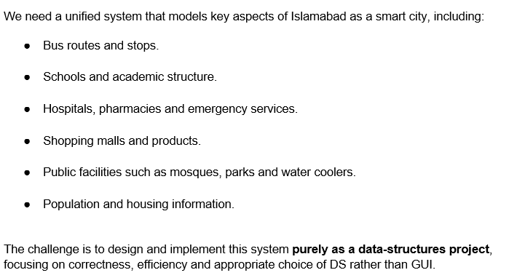

2.2 Core Objectives
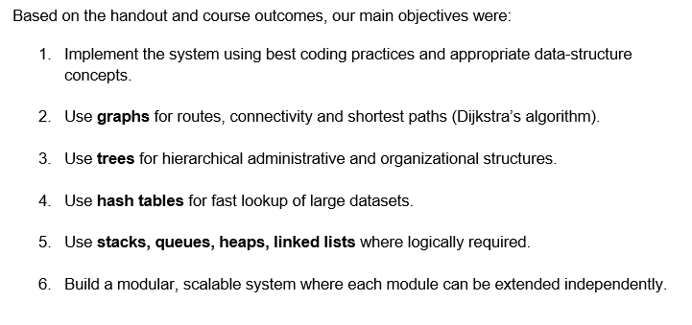

3. System Overview & Architecture

3.1 High-Level Modules
The system is divided into the following main modules, as required by the specification:
- Transport Sector (Graph-based)
- Education Sector (Tree + Hashing)
- Medical Sector (Hashing + Heap)
- Population & Housing Sector (Tree + Hashing)
- Public Facilities
- Commercial (Mall System)
A central city graph (Graph cityGraph) stores all locations (bus stops, facilities, malls etc.) and represents the road network. Each module either interacts directly with this graph or uses its own data structures (trees, heaps, hash tables).

3.2 Global Data Representation
We use statically sized arrays for main entities:
- Bus buses[50];, BusStop stops[50];
- School schools[50];, Hospital hospitals[50];
- Pharmacy pharmacies[100];, Citizen citizens[200];
- Mall malls[20];, Product products[100];
- PublicFacility facilities[50];
This simplifies memory management for a teaching project and matches the relatively small sample datasets from the handout.

3.3 Core Shared Data Structures
Shared objects instantiated in Source.cpp include:
- Graph cityGraph; – adjacency-list graph for all locations.
- HashTable instances for buses, citizens, medicines, schools, hospitals and products.
- NaryTree islamabadTree;, NaryTree schoolOrgTree; – for city and school hierarchies.
- MaxHeap emergencyBedHeap; – hospital emergency beds as a priority queue.
- Stack routeHistory; – route travel history.
- CircularQueue passengerQueue; – passenger management.
The main function loads CSV data, initializes all structures, and then serves an interactive menu for the user.

4. Dataset & File Handling

4.1 Datasets
The project uses CSV files closely based on the sample dataset given in Appendix-1 of the handout.
- stops.csv – bus stop IDs, names and coordinates.
- buses.csv – bus number, company, current stop, and full route.
- schools.csv – school ID, name, sector, rating, subjects.
- hospitals.csv – hospital ID, name, sector, emergency beds, specialization.
- pharmacies.csv – pharmacy ID, name, sector, medicine, formula, price.
- population.csv – CNIC, name, age, sector, street, house number, occupation.

4.2 CSV Parsing & Loading
All file loading functions are implemented in Source.cpp, under Section 1: File Loading Functions.
Example – stops loading:
- loadStops("SmartCity_dataset/stops.csv")
  - Parses each line.
  - Fills stops[] array with ID, name and coordinates.
  - Immediately adds each stop as a vertex in cityGraph with type "stop".
Similar logic is used for buses, schools, hospitals, pharmacies and population:
- loadBuses also builds a linked list route for each bus and inserts it into busHashTable.
- loadHospitals populates hospitals[], adds entries to hospitalHashTable and emergencyBedHeap.
- loadPharmacies adds medicines to medicineHashTable by both name and formula.
- loadPopulation fills citizens[] and stores CNIC in citizenHashTable.
A helper loadAllData() function calls all loaders sequentially.

5. Data Structures & Algorithms
This section summarises what we implemented and why it is appropriate. (You can attach the detailed DS report as an appendix if your teacher wants more depth.)

5.1 Singly Linked List
Implementation:
- struct ListNode with string data and ListNode* next.
- class LinkedList with ListNode* head and int size, providing:
  - insertAtEnd, insertAtBeginning, deleteNode, search, display etc.
Usage:
- Each Bus has LinkedList* route storing its stop IDs in order.
- connectBusStops() traverses these lists to add graph edges between consecutive stops.
Justification:
- Routes are naturally sequential and can have variable length.
- We only need traversal and append, so a simple linked list is sufficient.
- This matches the requirement that bus routes must be stored using singly linked lists.
Complexity:
Let n be route length:
- Insert at end: O(n) (no tail pointer).
- Search/delete: O(n).
For small route sizes, this overhead is acceptable.

5.2 Stack (Array-Based)
Implementation:
- class Stack with string items[MAX_STACK_SIZE] and int top.
- Main methods: push, pop, peek, isEmpty, display.
Usage:
- Global Stack routeHistory; stores sequences of stops for each shortest path computed.
- After Dijkstra finds a path, each stop ID is pushed.
- The user can display route history in LIFO order.
Justification:
- The requirement explicitly demands a manually created stack for route history.
- LIFO order naturally models “most recent routes first”.
Complexity:
- push, pop, peek: O(1).
- display: O(k) for k history entries.

5.3 Circular Queue
Implementation:
- class CircularQueue with string items[MAX_QUEUE_SIZE], front, rear, count.
- Supports enqueue, dequeue, peekFront, display.
Usage:
- Global CircularQueue passengerQueue; handles passenger simulation.
- Transport menu options:
  - Add passenger to queue.
  - Process next passenger.
  - Display entire queue.
Justification:
- FIFO behaviour matches real bus-stop queues.
- The rubric requires circular queue for passenger handling.
Complexity:
- enqueue, dequeue, peekFront: O(1).
- display: O(n) for n passengers.

5.4 Hash Table with Separate Chaining
Implementation:
- struct HashNode { string key, value; HashNode* next; }.
- class HashTable with HashNode* table[HASH_TABLE_SIZE]; and a manual polynomial rolling hash.
- Operations: insert, search, contains, remove, display.
Usage:
Multiple hash tables are used:
- busHashTable – bus number → bus name/info.
- citizenHashTable – CNIC → citizen name.
- schoolHashTable – school ID → name.
- hospitalHashTable – hospital ID → name.
- medicineHashTable – medicine name/formula → pharmacy + price.
- productHashTable – product name → mall ID, category, price.
Justification:
- Specification demands manual hashing with separate chaining and no built-in hash maps.
- Many operations are “search by key” (bus number, CNIC, medicine name), ideal for approximate O(1) access.
Complexity:
- Average insert, search, delete: O(1) with low load factor.
- Worst case (all collisions in one bucket): O(N), where N is number of elements.

5.5 N-ary Tree (General Tree)
Implementation:
- struct TreeNode with string name, type, data; TreeNode* children[MAX_CHILDREN]; int childCount; TreeNode* parent;.
- class NaryTree with:
  - setRoot, addChild, findNode, display, getRoot.
Usage:
- Islamabad City Hierarchy
  - islamabadTree: Islamabad → Sector → Street → House → Citizen.
  - Constructed in initializeIslamabadTree() from citizens[].
- School Organization
  - schoolOrgTree: All Schools → School → Department → Class.
  - Constructed in initializeSchoolTree().
Justification:
- The handout requires:
  - Islamabad hierarchy as an N-ary tree.
  - School system as a 3-level tree: School → Department → Class.
- N-ary trees naturally model nodes with many children (many streets per sector, many classes per department).
Complexity:
- addChild with known parent pointer: O(1).
- findNode by name: O(T) where T is total nodes.
- display: O(T).

5.6 Graph (Adjacency List) & Dijkstra
Implementation:
- struct EdgeNode { int destIndex; double weight; EdgeNode* next; };
- struct GraphVertex { string id, name, type; double latitude, longitude; EdgeNode* edges; };
- class Graph:
  - addVertex(id, name, lat, lon, type)
  - addEdge(sourceId, destId, weight) and addUndirectedEdge(id1, id2, weight)
  - addEdgeAuto(id1, id2) to compute weight from coordinates.
  - dijkstra(startId, distances[], previous[], visited[])
  - getShortestPath(startId, endId, path[], pathLength)
  - findNearest(startId, type)
Usage:
- All bus stops, public facilities and malls are added as vertices.
- connectBusStops() connects consecutive stops along each bus route using addEdgeAuto.
- Public facilities and malls are attached via undirected edges to their nearest stops.
- Transport menu uses cityGraph.getShortestPath to compute shortest path between two stop IDs.
- Facilities and mall modules use cityGraph.findNearest(startStop, facilityType) or "mall" to find nearest facility or mall.
Justification:
- Graph with adjacency list is required and suits a sparsely connected city network.
- Dijkstra’s algorithm is necessary for weighted shortest paths and nearest-location queries.
Complexity (without heap optimization):
- Let V be vertices and E edges.
- dijkstra: O(V² + E) due to linear search for next minimum distance.
- getShortestPath: O(V² + E) for Dijkstra + O(V) for path reconstruction.
- findNearest: O(V² + E) for Dijkstra + O(V) scanning for minimum distance of given type.

5.7 Priority Queues (Heaps)
Implementation:
- struct HeapItem { int priority; string data; };
- class MinHeap and class MaxHeap with HeapItem items[MAX_HEAP_SIZE].
- Standard heap operations: insert, extractMin/extractMax, peekMin/peekMax, heapifyUp, heapifyDown.
Usage:
- School Rankings (MinHeap)
  - For each school, we insert with priority -rating * 10 so that higher rating becomes “smaller” priority.
  - displaySchoolRankings() repeatedly extracts to print schools from highest to lowest rating.
- Emergency Beds (MaxHeap)
  - emergencyBedHeap stores hospitals with priority equal to number of emergency beds.
  - Used to identify hospitals with most emergency capacity.
Justification:
- Rubric demands manual implementation of a binary min-heap for priority queue.
- Heaps provide O(log n) insert and extract operations, efficient for ranking tasks.

6. Module-wise Design & Features

6.1 Transport Module
Key features:
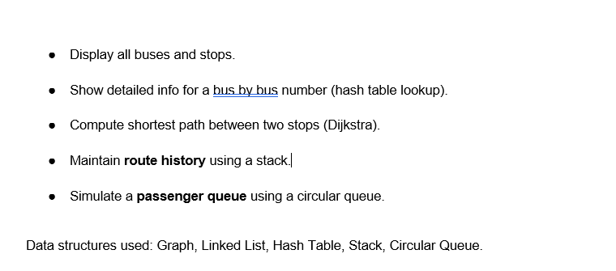

6.2 Education Module
Features:
- Display all schools with rating and subjects.
- Search schools offering a specific subject.
- Build and display school organization tree (All Schools → School → Department → Class).
- Rank schools using a min-heap based priority queue.
Data structures: N-ary tree, MinHeap, Hash Table (for IDs), arrays.

6.3 Medical Module
Features:
- Display all hospitals, and list hospital with most emergency beds (MaxHeap).
- Display and search pharmacies by medicine name or formula using medicineHashTable.
Data structures: MaxHeap, Hash Table, arrays.

6.4 Population & Housing Module
Features:
- Build Islamabad hierarchy: Islamabad → Sectors → Streets → Houses → Citizens.
- Display all citizens with details.
- Search citizens by CNIC (hash table).
- Generate:
  - Age distribution report.
  - Occupation summary report.
Data structures: N-ary tree, Hash Table, arrays.

6.5 Public Facilities Module
Features:
- Add and list public facilities (mosques, parks, water coolers).
- Add all facilities as graph vertices and connect them to nearby stops.
- Find nearest facility by type using cityGraph.findNearest.
Data structures: Graph, arrays.

6.6 Commercial (Mall) Module
Features:
- Add malls as graph vertices and connect them to the city graph.
- Add products and index them in productHashTable.
- Search products by name and by category.
- Find nearest mall from a given stop via graph.
Data structures: Graph, Hash Table, arrays.

7. Complexity Summary
A brief complexity summary for major DS operations:
Data Structure | Operation (Typical) | Complexity
Linked List | Insert/search/delete | O(n)
Stack (array) | Push / Pop / Peek | O(1)
Circular Queue | Enqueue / Dequeue / PeekFront | O(1)
Hash Table | Avg insert/search/delete | O(1)
N-ary Tree | Find node / Display | O(T)
Graph + Dijkstra | Shortest path / Nearest facility | O(V² + E)
Min/Max Heap | Insert / ExtractMin/Max | O(log n)
These complexities meet the project’s requirement to provide time-complexity analysis for major operations.

8. Implementation Details
- Language: C++
- Input/Output: Console-based, text menus.
- Restrictions:
  - No STL containers for core structures.
  - Manual implementation of graph, tree, hash table, heap, stack and queue.
The code is split into:
- Header.h – All struct and class definitions for data structures and entity types.
- Source.cpp – Global data, file loading, module functions and main() entry point.

9. Testing & Sample Scenarios
We performed manual testing using the provided sample datasets and custom inputs. Typical test scenarios included:
- Transport
  - Load sample stops and buses.
  - Confirm edges created correctly by checking shortest path between Stop1 and Stop4.
  - Add multiple passengers, dequeue them and verify FIFO order.
- Education
  - Verify that school tree shows correct hierarchy.
  - Search for subject "Math" and check that all math-offering schools are printed.
- Medical
  - Confirm that hospital with maximum emergency beds is correctly identified by MaxHeap.
  - Search for Paracetamol and Ibuprofen by name and formula via medicineHashTable.
- Population & Housing
  - Display Islamabad hierarchy and check nesting for sectors and streets.
  - Verify age distribution and occupation summary for the sample population.
- Public Facilities & Mall
  - Confirm nearest mosque from each bus stop based on sample graph.
  - Search products by name and verify mall IDs and categories.

10. Division of Work (Example – Adjust to Match Your Group)
Based on comments in the code header:
- Member 1:
  - LinkedList, Stack, CircularQueue, HashTable core implementations.
  - Transport module, Public Facilities module, Mall module.
- Member 2:
  - N-ary Tree implementation.
  - Education module (school tree, subject search, rankings).
  - Heaps (MinHeap/MaxHeap) and hospital emergency beds logic.
- Member 3:
  - Graph implementation (adjacency list, Dijkstra).
  - File loading and CSV parsing functions.
  - Integration in main() and overall menu flow.
You can replace this with your actual contributions if different.

11. Conclusion & Future Work

This Smart City Management System shows how a realistic, modular city-simulation application is built on top of classical data structures. All necessary data structures like graphs with Dijkstra, N- ary trees, hash tables with independent chaining, heaps, stacks, queues, and linked lists—are manually implemented and incorporated into useful modules for public facilities, transportation, education, healthcare, population & housing, and business operations.

11.1 Achievements
- Designed and implemented a fully functional console-based smart city model for Islamabad.
- Correctly used and justified all required data structures.
- Provided basic complexity analysis for key operations.
- Ensured modular architecture so each sector/module can be extended independently.

